Chapter 17, Problem 40.

The signal in Fig. 17.76(a) is applied to the circuit in Fig. 17.76(b). Find v_{o}(t).
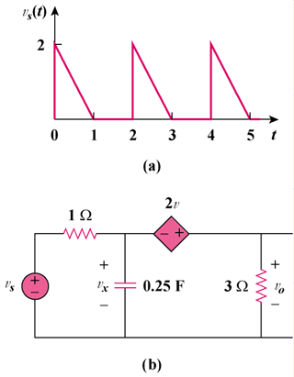

2v_{x}

Figure 17.76
For Prob. 17.40.

